Software Engineering Year 12

Programming Project

**Project Documentation: Ryan Hanna**

# Table of Contents

Defining and understanding 3

Task Definition 3

Functional and non-functional specifications 4

Functional Specifications 4

Non-functional Specifications 4

Data Types & Structures 5

Planning and designing 6

Storyboard 6

Data Flow Diagram (Level 0 Context Diagram) 7

Data Flow Diagram (Level 1) 8

Structure Chart 9

Algorithms 10

Mainline Algorithm 10

GANTT Chart 11

Implementation 12

Development log 12

Testing 13

Test Table 13

Project showcase 14

Repository 14

Evaluation 15

Project Reflection 15

# Defining and understanding

## Task Definition

The issue I aim to address is that teaching theory of software engineering can be disengaging for younger students such as people from years 7-12, the idea for this project is to design a fun and engaging game to help teach the process of design and planning through interactive and fun gameplay elements.

Some limitations will be creating a AAA game and covering all parts of software engineering.

My intention will be to create some sort of game with a factory/tycoon style gameplay aimed at teaching fundamental design processes such as DFD diagrams, Classes, Structure Charts, etc…

Some primary features of the project will include:

* Gameplay system where the player will create a system by connecting and creating processes to complete a goal
* A zoomed-out view of the created system will be displayed as a DFD
* Functions such as a system design page where the player can layout a structure for their factory in a structure chart layout

## Functional and non-functional specifications

### Functional Specifications

|  |  |
| --- | --- |
| Requirement | Description |
| **Functions which replicate the process of designing and planning software projects** | **Functions such as the main factory layout when zoomed out should be visualised as a DFD, or when creating new factories and layouts they should be done as a structure chart like method.** |
| **Extension Game** | **Should be a small game able to be accessed as a browser extension, this means its quickly accessible and if Uploaded to the Chrome Extensions store can be easily installed and played. Also allows for offline gameplay with possible syncing capabilities for saving games when reconnecting** |
| **tool for teaching Software Engineering topics**  **(DFD, IPO)** | **Using functions within the game to teach certain topics within software engineering to make learning an interactive and fun experience which in turn is better for memory.** |
| **Game Objectives:** | **Take Orders from clients and deliver the correct Files and packages back.** |
| **Difficulty System:** | **More customers to serve at a time**  **Larger orders** |
| **Needed functions for game:** | **Orders from client**  **Package generator/button**  **Files generator/button**  **Storage system for packages and Files**  **Transport system for items** |

### Non-functional Specifications

|  |  |
| --- | --- |
| **Requirement** | **Description** |
| Fun and Engaging | The design and gameplay should be fun and engaging for the user so that it doesn't feel like learning. |
| Simplistic yet pleasing Style | The game should be a simplistic and easy to learn game and the style should be pleasing to look at |
| * Add a vignette to game screen | Creates a fun playful feeling scene rather than a flat harsh background |
| NATS IDEAS:   * Falling boxes cursor physics (bounce of cursor or avoid it while falling) * News Paper with factory status/leaderboard * Fun animations for***everything*** | Animation ideas:  . Pop-in/out when placing or deleting tiles  . Smooth rotation and flipping animation when transforming tiles  . Title screen animation (falling/rotating packages)  . Loading animation (Box opening and unfolding)  . Screen load animation when first loading tiles |
| Intuitive gameplay | The buttons and elements within the game should be easy to use and understand, game theme should be obvious |
| Improvements to placement/gameplay flow | * Drag to place tiles |

## Data Types & Structures

## Data Dictionary

|  |  |  |  |  |  |  |
| --- | --- | --- | --- | --- | --- | --- |
| **Variable** | **Data Type** | **Format** | **Size** | **Description** | **Example** | **Validation** |
| TileData | arrays | N. X,X,X,X,X  N. X,X,X,X,X  N. X,X,X,X,X | 140*6*n | The main array of all tiles and their data | 1. tile  2. tile : data  3. tiles  4. tile: data | Row and Col of each tiles is displayed infront of tile, Only tiles that have data in them have their properties displayed |
| Coins | integer | N... | 8*n | Number of coins earnt from completed missions | 10 | Always an integer not a floating point |
| Current Mission | string | X...X, NN | 3-8 | Stored Mission currently loaded by name and required file amount | Janet, 13 | Names are generated |
| Tile | array | X,X,X,X,X | 6*n | Array holding each tiles individual data | Straight road, row: 12, col: 10, entry, exits, type | Type is based on tiles surrounding tiles |

## Class Diagrams

|  |  |  |
| --- | --- | --- |
| **CLASS NAME: Vehicle** | **CLASS NAME: Tiles** | **CLASS NAME: Buttons** |
| **ATRIBUTES: Load, Speed, Img, Size, Xpos, Ypos** | **ATRIBUTES: Xpos, Ypos, Img, colour, size, transforms (rotate, flip), state, type** | **ATRIBUTES: size, colour, border, margin,** |
| METHODS: Move, Deliver, Spawn, Pack (trolley entering a package factory) | **METHODS: Place, rotate, flip, delete, getTileType** | **METHODS: onclick, opensettings, openmissions, openupgrades, opentutorial, openkeybinds, openstats, resetgame, change light mode** |

# Planning and designing

## AI planning

### PROMT

Ive decided to use AI to help me come up with ways of implementing software fundamentals:  
**here is the promt for refrence:**  
hey ive got this game im making which is meant to teach the fundamentals of software engineering mainly the desing/planning face, its a tycoon factory type game and ill link the code so you can look at it, would you be able to help me come up with some ways i could implement things like teaching things like: classes, structure charts, decision trees and so on...

also i already have a plan for teaching DFD's which will be a zoom function which turns the screen into a zoomed out view of the factories that are connected but display it all as a DFD diagram style, but i dont want to create this just yet. ive included the main js file for the project but i also have a small html and manifest file as this game is a chrome extention, and i also have a CSS file so just ask if you want to see that aswell since i can only send one at a time

**Teaching Software Engineering Concepts Through Factory Game**

Your game has great potential for teaching software engineering concepts in an interactive way. Here are some ideas for implementing classes, structure charts, decision trees, and other concepts:

### 1. Classes and OOP Concepts

**Implementation Idea:**

* Create a "Blueprint Mode" where players design classes that represent different factory components
* Each class could have properties (like production rate, capacity) and methods (like produce(), connect())

**In-Game Representation:**

class FactoryComponent {  
 constructor(type, inputs, outputs) {  
 this.type = type; // "conveyor", "assembler", "packager"  
 this.inputs = inputs; // array of required inputs  
 this.outputs = outputs; // array of produced outputs  
 this.connections = []; // other connected components  
 }  
  
 connect(targetComponent) {  
 this.connections.push(targetComponent);  
 // Visual connection appears in game  
 }  
}

**Teaching Moment:**

* Players could see how changing class properties affects factory performance
* Inheritance could be shown by having specialized versions of basic components

### 2. Structure Charts

**Implementation Idea:**

* Add a "Design View" that shows the hierarchical structure of the factory
* Components become modules in the structure chart
* Data flows between them become arrows showing dependencies

**Game Mechanic:**

* Players must organize their factory into logical modules
* Well-structured factories get efficiency bonuses
* Spaghetti factories have penalties or error conditions

### 3. Decision Trees

**Implementation Idea:**

* Create a "Routing Challenge" where players must set up decision points in their factory
* Conveyor belts could branch based on conditions (like item type or quality)

**Example Decision Tree Implementation:**

function routeItem(item) {  
 if (item.quality < threshold) {  
 sendToRecycling(item);  
 } else if (item.type === 'fragile') {  
 sendToSpecialPackaging(item);  
 } else {  
 sendToStandardShipping(item);  
 }  
}

**Teaching Moment:**

* Visualize the decision paths in the factory
* Show how complex decisions can be broken down into simple binary choices

### 4. State Machines

**Implementation Idea:**

* Certain machines could have different states (idle, working, jammed, maintenance)
* Players must design systems that handle all possible states

**Example:**

class Machine {  
 constructor() {  
 this.state = 'idle';  
 }  
   
 start() {  
 if (this.state === 'idle') {  
 this.state = 'working';  
 }  
 }  
   
 // Other state transitions...  
}

### 5. Algorithm Efficiency

**Implementation Idea:**

* Add a "Processing Challenge" where players must optimize item routing
* Show Big-O notation for different routing configurations
* Fastest solutions get bonuses

### 6. Version Control Concepts

**Implementation Idea:**

* Add a "Save System" that shows branching factory designs
* Players can experiment with different layouts in branches
* They must merge successful changes back to the main factory

### 7. Testing Concepts

**Implementation Idea:**

* Add a "Quality Assurance" phase where players design test cases
* They must create sample inputs and verify outputs work as expected
* Coverage metrics show how thorough their testing is

### Implementation Suggestions

* **Progressive Complexity:**
* Start with basic concepts and introduce more advanced ones as players progress
* Each level could focus on a different SE concept
* **Visual Feedback:**
* Use different colors/styles to represent different concepts
* For DFDs, you could use standard shapes (circles for processes, etc.)
* **Challenge Levels:**
* "Refactoring Challenge" - Improve an existing messy factory
* "Scalability Test" - See how the factory handles increasing load
* **Documentation Tasks:**
* Players could create simple comments/documentation for their designs
* Well-documented factories get maintenance bonuses

Would you like me to elaborate on any of these ideas or suggest how to modify specific parts of your existing code to implement them? I can also help with the CSS or other files if you'd like to share them.

The game mechanics you already have (like tile connections and mission systems) provide a great foundation for these concepts. The key will be adding the software engineering layer on top while keeping the game fun and engaging.

## Storyboard

|  |  |  |  |
| --- | --- | --- | --- |
| Title Screen | **Settings** | **Game Screen** | **DFD Mode** |

## Data Flow Diagram (Level 0 Context Diagram)

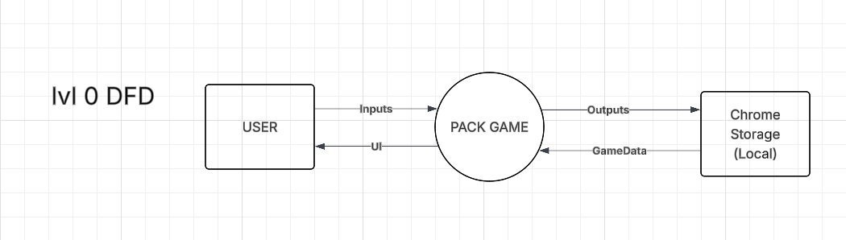

## Data Flow Diagram (Level 1)

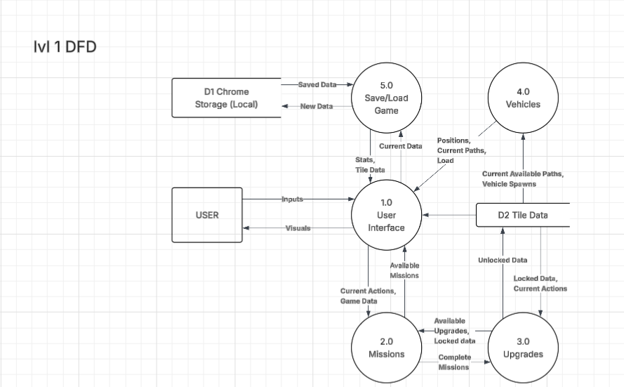

## Structure Chart

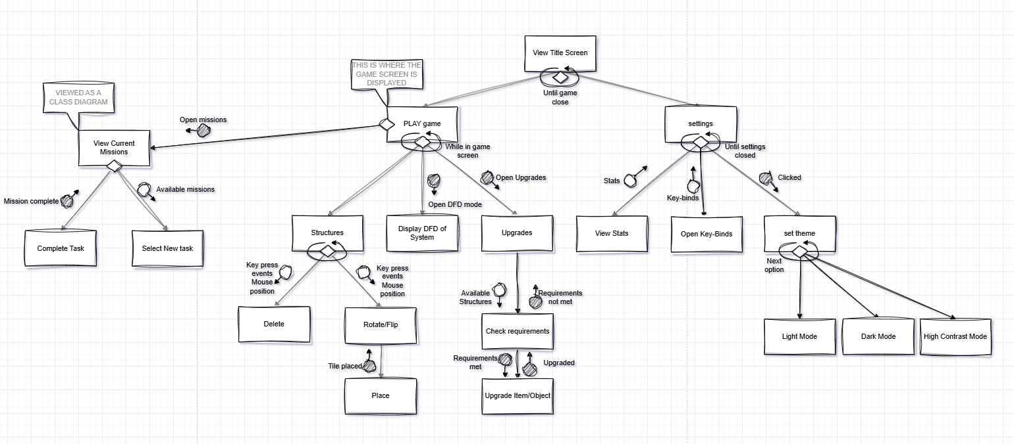

## Algorithms

## Mainline Algorithm

**START GAME**

**Initialize global variables**

**Load saved game data from storage**

**Call LoadTitleScreen()**

**FUNCTION LoadTitleScreen**

**Display title UI and background animation**

**WAIT for user to click the title image**

**CALL LoadGameScreen()**

**FUNCTION LoadGameScreen**

**Set gameState to TRUE**

**Clear title screen**

**Display game UI (grid, coins, missions, etc.)**

**Load current missions and set currentMission**

**CALL CreateTileGrid()**

**GAME LOOP (runs with user interaction)**

**ON mouse move:**

**Show/hide dropdown menus**

**Handle preview updates**

**ON tile click:**

**Place selected tile**

**CALL TileCheck()**

**Update vehicle paths**

**ON key press:**

**Handle shortcuts (rotate, flip, delete, etc.)**

**FUNCTION TileCheck**

**FOR each tile in grid:**

**Detect tile type and rotation**

**Store entry/exit points**

**Determine connections to neighbors**

**CALL VehicleManager.UpdateAllPaths()**

**FUNCTION VehicleManager.UpdateAllPaths**

**FOR each vehicle:**

**Find new valid path**

**IF valid:**

**Animate vehicle along path**

**IF vehicle reaches destination:**

**CALL IncrementDelivered()**

**FUNCTION IncrementDelivered**

**Increase delivery count**

**IF delivery count >= currentMission.amount AND mission not already completed:**

**Unlock new structures (if any)**

**Add coins based on difficulty**

**Save progress**

**Generate new mission**

**Set as currentMission**

**SETTINGS & MISC**

**User may open settings, stats, keybinds, or tutorial**

**User may reset game (clears all data and reloads title)**

**GAME CONTINUES until user exits or resets**

## 

## GANTT Chart

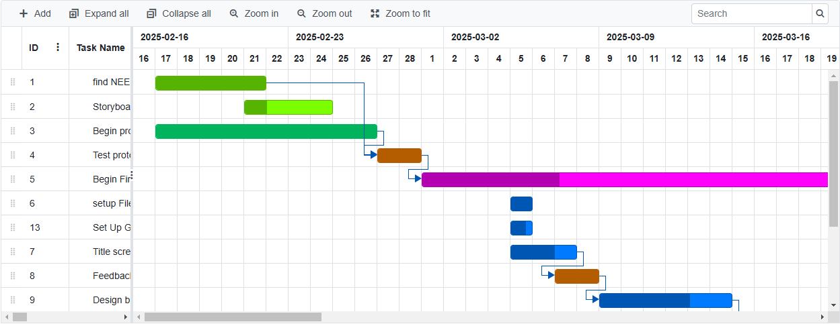

# Implementation

## LOGBOOK

|  |  |
| --- | --- |
| **Development Log Entry 1** | |
| Date | 26/2/2025 |
| Week Number | Week 4 |
| Summary of Work Done  **UPDATES...**  Began Planning and working on setting up file directory and first prototype  **BUGS/ERRORS...**  First issue was figuring out how to set up a chrome extension  Then I encountered a few issues with coding in mainly JavaScript and CSS.  **BUG FIXES...**  To solve these issues i used ChatGPT to show me how to set up a chrome extension and then practice a bunch of JavaScript and CSS using w3schools a lot to learn a bunch of new syntax. | |
| Milestones Achieved | Got the chrome extension working and I recently finished the title screen of the game along with the logo and some sprite designs. |

|  |  |
| --- | --- |
| **Development Log Entry 2** | |
| Date | 06/3/2025 |
| Week Number | Week 6 |
| Summary of Work Done  **UPDATES...**  Did a bunch of work on setting up a game screen and created some more sprites, I worked on a tiling system and have been trying to get placing and deleting structures working.  **BUGS/ERRORS...**  Alot! I have had a lot of issues with getting the game screen to work as i need a tile system and first tried making a grid then snapping structures to the grid but that would be way to complicated and a messy way. Finally, I encountered a TON of bugs with trying to add animation to the tiles when rotating, flipping, and placing.  **BUG FIXES...**  To fix the game screen I learnt how to make a tiling system using tables and cells to create a grid and then edit their style with structures, next I had to find a way to send variables to my CSS file as I needed to update the transform functions dynamically when rotating or flipping tiles. This took me a few days to get working to a good level, but I'm still stuck with some glitching that i will leave to fix later as it's not really impacting the gameplay or my progress. | |
| Milestones Achieved | Game screen works with a functioning tiling system.  structures can be placed, rotated, flipped, and deleted. |

|  |  |
| --- | --- |
| Development Log Entry 3 | |
| Date | 11/3/2025 |
| Week Number | Week 7 |
| Summary of Work Done  UPDATES...  Worked on adding some quality-of-life elements like key binds and buttons for changing tiles, started to work on logic for hold to place and also adding TRUCKS!! and I also uploaded the game to the chrome store!  **BUGS/ERRORS...**  I had a few errors with setting the index and some variable errors but other than that progress has been pretty good.  **BUG FIXES...**  I just changed the way data was passed between the pickSprite function and the placing function so that they are linked instead of seperate. | |
| Milestones Achieved | Uploaded game to Chrome Store!!!  Added keybinds to game  Quality of life changes |

|  |  |
| --- | --- |
| Development Log Entry 4 | |
| Date | 22/3/2025 |
| Week Number | Week 8 |
| Summary of Work Done  UPDATES...  After having a few people test my game I have been given some feedback and bugs they encountered.  **BUGS/ERRORS...**   * Structures can be placed at the bottom of the screen on unseen tiles. * Touch screen can't drag * When dragging, placement only starts on next entered tile not the current tile. * Just created a bug: When you delete tiles and then select another tile the preview places tiles without clicking.   **BUG FIXES...**   * I changed the set rows of cells that are made because it was 15 rows with 10 columns but that meant the 15th row was a single pixel at the bottom of the screen so i changed it to 14 rows which fixed the issue. * This is an issue I'm not sure how to solve so I will leave the touch screen to have limited ability to play. * Added an event checker so that if you enter a cell while holding down then get the tile you just left row and column and fill that as well | |
| Milestones Achieved | Solved some main issues from user feedback gained from beta testing the prototype  UPDATED GAME TO VERSION 1.2 FEEDBACK UPDATE |

|  |  |
| --- | --- |
| **Development Log Entry 5** | |
| Date | 4/4/2025 |
| Week Number | Week 9 |
| Summary of Work Done  **UPDATES...**  Saving progress has taken me a while to figure out but it really wasn't that complicated, I first ran through each tile and its data then sent that data to chromes local storage, then when you open the game a function is run were I get the local data and run through each item, then I set the tiles data to the saved local data.  **RESEARCH...**  Research: I was testing some things on Tinker CAD when I noticed that it had a function when you make a circuit there is a button you can press to turn it into a drawn-up circuit. I also found a similar thing in Onshape as you can select create drawing of model and it creates a projected version. I am looking into the code on how they work so that i can use a similar method in my own game when creating the DFD screen transition.  **HOW I THINK IT WORKS...**  From what i can tell they use a similar function to my save function where all the data of an item is saved to an array, then when you open or create the drawing version it was already there just hidden a layer below. So, in the background while creating your projects it was always creating the drawing. This happens when you place an item every detail is sent to its array as a long string of numbers, then the loader function will sort that string with a specific pattern and apply each set of data to the drawing interface. So, for this to work each game item must have a DFD variant which can be called by a specific ID and placed at the tiles location but hidden on a lower level until called.  **UPDATES...**  Finaly I've been working on a menu type of thing in game so when you hover your mouse at the bottom of the game screen a tab pops up and you have your menus like settings, missions and so on.  **BUGS/ERRORS...**   * I tried to create a data base to save tile data, but this was complicated and didn't work with chrome extensions so i had to find a new method * After saving progress then re-opening the game the tiles that have been saved do not animate like the rest when you first click play (PACK)   **BUG FIXES...**   * After a lot of searching, I came across chromes local storage, which was super simple to use, this gave me a huge advantage with being able to easily save and send data straight into the browser, this meant that the data could easily be accessed and used. * I tried solving this issue by giving the saved tiles an added transform of scale which is what the animation uses but i think I have to find an earlier point of adding it because it's removing the saved tiles data. | |
| Milestones Achieved | SAVING FUNCTION, small menu popup working without buttons YET  Updated the game to version 1.3 SAVE UPDATE |

|  |  |
| --- | --- |
| **Development Log Entry 6** | |
| Date | 4/4/2025 |
| Week Number | Week 10 |
| Summary of Work Done  **UPDATES...**  Saving progress has taken me a while to figure out but it really wasn't that complicated, I first ran through each tile and its data then sent that data to chromes local storage, then when you open the game a function is run were I get the local data and run through each item, then I set the tiles data to the saved local data.  **RESEARCH...**  Research: I was testing some things on Tinker CAD when I noticed that it had a function when you make a circuit there is a button you can press to turn it into a drawn-up circuit. I also found a similar thing in Onshape as you can select create drawing of model and it creates a projected version. I am looking into the code on how they work so that i can use a similar method in my own game when creating the DFD screen transition.  **HOW I THINK IT WORKS...**  From what i can tell they use a similar function to my save function where all the data of an item is saved to an array, then when you open or create the drawing version it was already there just hidden a layer below. So, in the background while creating your projects it was always creating the drawing. This happens when you place an item every detail is sent to its array as a long string of numbers, then the loader function will sort that string with a specific pattern and apply each set of data to the drawing interface. So, for this to work each game item must have a DFD variant which can be called by a specific ID and placed at the tiles location but hidden on a lower level until called.  **UPDATES...**  Finaly I've been working on a menu type of thing in game so when you hover your mouse at the bottom of the game screen a tab pops up and you have your menus like settings, missions and so on. | |
| Milestones Achieved | Figured out a method for DFD zoom function |

|  |  |
| --- | --- |
| **Development Log Entry 7** | |
| Date | 14/4/2025 |
| Week Number | Week 11 |
| Summary of Work Done  **UPDATES...**  Not to much happened this week I have just been working on a bunch of bug fixes and working on documentation | |
| Milestones Achieved | Small bugs fixed |

|  |  |
| --- | --- |
| **Development Log Entry 8** | |
| Date | 25/4/2025 |
| Week Number | Holidays Week 2 |
| Summary of Work Done  **UPDATES...**  I have fixed some small visual bugs and also moved a lot of the functions of the screen when not in use to lessen the clutter.  **BUGS/ERRORS...**   * While trying to add some buttons to settings I came across an error with calling a function I had set inside the DOMcontentloaded, I didn't notice that I had all the rest of my code outside that which was causing errors * I added the erase function to be a button in tile selection but for some reason when you select another tile then try use the erase button it doesn't work. * Can't figure out how to make the key binds hide when you click on the button again   **BUG FIXES...**   * Simply moved all the code into the main DOM function * ? * I've tried a few different solutions, but none are working, I've tried deleting the entire settings and reloading it but nothing happens, tried clearing the div but not working, tried putting the text into a new div, also not working   **UPDATES...**  I updated the tile selection by adding borders to your selected tile, also made it drop down from the top of the screen when you move your mouse near the top, this was my way of clearing some clutter and it was blocking the topmost row of tiles. | |
| Milestones Achieved | Tile selection is now a slide down menu and are much cleaner |

|  |  |
| --- | --- |
| **Development Log Entry 9** | |
| Date | 28/4/2025 |
| Week Number | TERM 3 Week 1 |
| Summary of Work Done  **UPDATES...**  Fixed and edited a lot of the CSS to match the style and look across the entire game because there were slight colour differences.  Because of this i have moved away from making any settings of buttons pixelated and custom as its much cleaner and nice to look at as styled css buttons  **BUGS/ERRORS...**   * Menu and settings can be opened at the same time   **BUG FIXES...**   * Made each one close the other when opened   **UPDATES...**  I updated the tile selection by adding borders to your selected tile, also made it drop down from the top of the screen when you move your mouse near the top, this was my way of clearing some clutter and it was blocking the topmost row of tiles.  **Tile Check Function:**  First I need it to define whether a tile is a out/in/end/connect/full, here are the tiles I have:   * straight road * turn road (the direction is based on its rotate variable and its rotateY(flip) variable * split road (straight road but allows another road to be connected/continued through its side * package factory * files factory * files storage * package storage   this doesnt count but it is a delete tile so we dont count it because its also not a part of the tile data  here is how each one is defined:  **OUT** - must be a road tile, rot/dir: facing away from a factory or storage tile, NOT: a continue from another road tile, connection: must be adjacent(orthogonally) to a factory or storage tile.  **IN** - must be a road tile, rot/dir: facing towards only the storage tiles NOT the factory tiles because nothing goes into them, connection: must be adjacent(orthogonally) to a storage tile.  **CONNECT** - must be a road tile, rot/dir: facing away from another road which is facing in to it (this means that a straight is a connect if a turn road is turning into it), connection: must be adjacent(orthogonally) to a road tile. ALSO: the split road can count as a connect even if only one entry point is connected to another road but also if both are connected.  **END** - must be a road tile, rot/dir: facing into the boarder on the screen, pos: must be on the tiles around the parameter of the screen NOT any on the inside, must also be a FULL tileType and a CONNECT tiletype  **FULL** - must be a part of a full connection road this means that this tile connects to another in the forward direction until one connected point is an END tiletype (this must also be the last tile in the full set but if it's a split tile then it's only an end if its facing and placed on the edge, also must be connected in the opposite direction untill it reaches either A: a factory, or B: a storage but then that storage must also have an IN type orthogonal to it which comes from a factory tile. all these types can be set to each tile; this means some tiles might have multiple types. | |
| Milestones Achieved | CSS is a coherent style across the game |

|  |  |
| --- | --- |
| **Development Log Entry 10** | |
| Date | 8/5/2025 |
| Week Number | TERM 3 Week 2 |
| Summary of Work Done  **UPDATES...**  I have spent the past week or so trying to fix my path tracing function  **BUGS/ERRORS...**   * Needed to run the adjacent tiles function after all tiles have been sorted and had their types set * Had to figure out how to sort through the tile types and exit/entry's * Needed to log the tiles their data and also all adjacent tiles to that tile and its data,   **BUG FIXES...**   * Made the loop set a counter, then when the counter was as long as the number of tiles then the tile type function runs * Fixed adjacent tiles function to work with new method for reading entry’s/exits * Used that same method to log all the data correctly, HERE IS THE FINNAL OUTPUT OF EVERYTING WORKING!   **UPDATES...**  This is huge because it means I can now start working on the tileCheck function that I talked about in the last log and then finally start working on getting TRUCKS in the game!!!  Now luckily, I had already made a version of the tileCheck function but I'm going to have to change it up a lot | |
| Milestones Achieved | TILE TYPE FUNCTION WORKS!!! |

|  |  |
| --- | --- |
| **Development Log Entry 11** | |
| Date | 15/5/2025 |
| Week Number | TERM 3 Week 3 |
| Summary of Work Done  **UPDATES...**  I am working on implementing vehicles using the path tracing function from last week  **BUGS/ERRORS...**   * *Spawning vehicles doesn't work with previous function* * *Cant detect spawn tiles* * I have a lot of Errors with tracking separate vehicles   **BUG FIXES...**   * Have to re-write path tracing function to work with vehicles * Created new states for tiles so that the vehicles spawn in the right positions * Still working on this   **UPDATES...**  Used AI to create auto random generated missions for continuous gameplay. | |
| Milestones Achieved | TRUCKS HAVE BEEN IMPLEMENTED |

|  |  |
| --- | --- |
| **Development Log Entry 12** | |
| Date | 21/5/2025 |
| Week Number | TERM 3 Week 5 |
| Summary of Work Done  **UPDATES...**  UI reworking  **BUGS/ERRORS...**   * *Many visual differences with ui*   **BUG FIXES...**   * Reworked the css file so that i have more global visuals   **UPDATES...**  Darker blueish tone with pixelated font has been added to all parts of the game | |
| Milestones Achieved | Globally consistent UI |

|  |  |
| --- | --- |
| **Development Log Entry 13** | |
| Date | 26/6/2025 |
| Week Number | TERM 3 Week 9 |
| Summary of Work Done  **UPDATES...**  After a long brake on this project im back with a new view on my game, I decided to go with a lighter slightly see-through UI and have added that to everything  I am also reworking the menu, with a smother and cleaner version, that also takes up less space  **BUGS/ERRORS...**   * *New menu buttons don't work*   **BUG FIXES...**   * Instead of coding the buttons in the html, create a js function that creates each button individually   **UPDATES...**  I took a lot of inspiration for apple's new Liquid Glass OS26. This is where I got the idea for semi see thru menu/settings container and buttons to bring a cozy and high-quality feel to the games UI | |
| Milestones Achieved | Updated cleaner UI + light/dark/HC modes + working menu |

|  |  |
| --- | --- |
| **Development Log Entry 14** | |
| Date | 02/7/2025 |
| Week Number | Holidays Week 1 |
| Summary of Work Done  **UPDATES...**  I have started to work on adding upgrades to the game to give the new coins a use. Also, I have added locked sections to the game forcing the users to play the game to progressively unlock more content, this not only helps with creating a more understandable and simple start for new users but also gives them an incentive to play rather than endless missions with pointless rewards.  I've also fixed the previous bugs mentioned such as the menu now works and they are all responsive to each other and user interactions  **BUGS/ERRORS...**   * *Eraser still doesn't work when selecting from drop down tile menu* * *Trucks duplicate when a trolley enters a package factory by spawning a truck at each package factory spawn* * *When dragging to place, if you accidently go off screen placing is held down until you press again*   **BUG FIXES...**   * I have to figure out a way of only activating the eraser function once the user hovers over a tile because when clicking on the eraser dropdown button you are’nt hovering over a tile which breaks the eraser. * Some how fix truck spawning * Create a check to see if the user has moved off screen, or some other check?   **UPDATES...**  ... | |
| Milestones Achieved | Locked sections + Upgrades |

|  |  |
| --- | --- |
| **Development Log Entry 15** | |
| Date | 14/7/2025 |
| Week Number | Holidays Week 2 |
| Summary of Work Done  **UPDATES...**  I have got upgrades to work but I'm not very happy with them, I finally began to create a tutorial and now have that working with a modular setup  **BUGS/ERRORS...**   * *Eraser still doesn't work when selecting from drop down tile menu* * *Trucks duplicate when a trolley enters a package factory by spawning a truck at each package factory spawn* * *When dragging to place, if you accidently go off screen placing is held down until you press again*   **BUG FIXES...**   * I have to figure out a way of only activating the eraser function once the user hovers over a tile because when clicking on the eraser dropdown button you are’nt hovering over a tile which breaks the eraser. * Some how fix truck spawning * Create a check to see if the user has moved off screen, or some other check?   **UPDATES...**  Working tutorial that reacts to in game actions based on required tasked from tutorial  Worked on documentation, created DFD lvl 0, 1 worked on structure chart and data dictionary/class diagrams | |
| Milestones Achieved | TUTORIAL! |

|  |  |
| --- | --- |
| **Development Log Entry 16** | |
| Date | 17/7/2025 |
| Week Number | Holidays Week 3 |
| Summary of Work Done  **UPDATES...**  A few things have happened this week, Ive got the tutorial working and responsive to gameplay, I Did start on creating the DFD mode but am deciding if I should keep it or not because I don't see any real use for it.  I also fixed the path finding function so that trolleys only spawn if their path is complete, but this broke truck spawning...  **BUGS/ERRORS...**   * *Eraser still doesn't work when selecting from drop down tile menu* * *Trucks duplicate when a trolley enters a package factory by spawning a truck at each package factory spawn* * *When dragging to place, if you accidently go off screen placing is held down until you press again* * *Trucks are broken again (;*   **BUG FIXES...**   * I have to figure out a way of only activating the eraser function once the user hovers over a tile because when clicking on the eraser dropdown button you aren't hovering over a tile which breaks the eraser. * Somehow fix truck spawning * Create a check to see if the user has moved off screen, or some other check? * Go back to the function and find the error, most likely the check for a complete path doesn't include a package factory as an end tile.   **UPDATES...**  Finalized base tutorial and DFD diagrams. | |
| Milestones Achieved | Semi-Final Key Update |

# Testing

## Test Table

* Students should complete their test table with a robust suite of tests [minimum 10 tests] that address a range of test types, including boundary values, path coverage, and exception handling. The most effective testing will lead to bug fixes, which have been briefly documented within the test table.

|  |  |  |  |  |  |  |  |
| --- | --- | --- | --- | --- | --- | --- | --- |
| Test ID | Category | Test Case Description | Input to Provide | Expected Output | Actual Output | Pass/Fail | Action Taken |
| Test 1 | Functional UI | Verify all buttons work and do so correctly | Click on all buttons | Buttons output correct functions | Reset Game -> reset alert -> main reset unlocked | Pass | N/A |
| Test 2 | Tile Placing | Tiles can be placed by clicks and dragging only when a structure is selected | Selected structure, click on tile, drag on tiles | structures are placed only once when clicked, and continually when dragging, in correct positions | selected structures were placed once on click in clicked tile, and continues when dragged | Pass | N/A |
| Test 3 | Tile Erasing |  |  |  |  | Pass | N/A |
| Test 4 | Locked structures | Test if locked areas are locked and prevent actions | Click on locked areas, use key binds to select locked areas | Nothing happens because section is locked | Nothing happened | Pass | N/A |
| Test 5 | Select missions | Test if missions selection works properly | Click on first mission called unlock roads, 3 | Mission tab shows unlock roads 0/3 | Unlock Roads 0/3 | Pass | N/A |
| Test 6 | Purchase upgrades | Upgrades only purchase when there are sufficient coins. Upgrades effect the game correctly | Earn 5 coins try purchase trolley upgrade for 10 coins, earn 10 coins try upgrade trolley, test if trolleys have been affected | Nothing, insufficient coins to purchase, upgrade lvl 1, trolleys deliver 2 files | Nothing, trolley lvl = 1, 2 files delivered per trolley | Pass | N/A |
| Test 7 | Create complete path, spawn Trolleys | Create a path, to see if a trolley spawns only once the path is valid | Place 1 file factory, place 2 roads that don't reach the edge leaving the factory, place roads facing out of the factory until touching the edge | Short path doesn't spawn a trolley, complete path spawns trolley | Nothing happened when the first path was placed, trolley spawned after last tile was placed to complete valid path | Pass | N/A |
| Test 9 | Reset Game | Test reset button to make sure all progress and any saved data has been reset | Press reset button, ok, RESET, check stats, game screen | All stats are cleared back to 0, game screen is cleared all tiles removed, all upgrades reset, all missions reset, all unlocked items relocked | All progress was lost all parts of game were reset properly | Pass | N/A |
| Test 10 | Save Game | Try saving the game and logging back in to see if all progress was saved | Press ‘s’, loading screen, close game, open game, check stats and progress made | All progress is saved and correctly loaded | Mostly all data was saved, placed tiles and coins and missions were saved, stats were not always saved properly and tiles re locked when game was re-opened | Pass half Fail | Nees to make sure locked tiles is sent to save and load functions |
| Test 11 | Test Game Loop | Test game play to make sure the game can be played infinitely | Play usual game objectives, missions upgrades, placing factories, roads etc | Game should never end or crash due to longer play, new missions should auto generate when complete | Game didn't crash, game was playable at base, all key functions worked correctly | Pass | N/A |
| Test 12 | Game Satisfaction Level |  |  | Satisfaction 10/10 |  |  | Keep Improving and polishing game, Add fun progression |
| Test 13 | Show game stats | Open the stats from the game menu to see if they display the correct results | Start a timer, Play the game and place 10 tiles, including 1 factory and 9 roads, complete 1 mission. Check stats, pause timer | Stats show,  Files delivered: 3 missions complete: 1  Tiles placed: 10  Time played: (time shown in timer) | I accidently placed 11 tiles not 10 | PASS??? | I don't think it will pass if i play the game for longer and do other things like reloading the saved game |
| Test 14 | Test tutorial skip function | Open tutorial, click to skip the text to see if it generates correctly | Click 3 times on tutorial to skip the steps | Tutorial text:“Now place the tile in the grid” | “Nhcoetw o sprcylr ae(ce4ent ,ht –hAte i dltreio)lpe dionw nt hseh ogurlidd appear with tiles” | FAIL | Make sure skip function correctly skips text rather than merging it. |
| Test 15 | Test trolley converting to truck at package factory | Connect file factory to package factory with roads, see if trolley spawns and if it converts to a truck when it reaches the package factory | Place file factory and packagefactory 3 tiles apart, place roads from the file to the package factory, place roads from the package factory to the edge | Trolley spawns, drives into package factory, converts to truck continues to edge to deliver larger amount than trolley | Trolley doesnt spawn | Fail | Fix valid path function to recognize package factories as a valid end piece if connected to file factory |

# Project showcase

## Repository

|  |  |
| --- | --- |
| **Heading** | **Detail** |
| Description | A fun game where you take orders for files and get them packed into packages and delivered by truck back to the clients. The game is intended for teaching students and anyone interested in software engineering development topics and tools such as DFD, server, packages, files, storage, and so on... |
| Installation Instructions | This is a chrome extension game intended to be installed of the chrome extension store under the name: “PACK!” by ryan hanna |
| How to Use | KeyBinds:  E | delete tile  T | next tile  S | save game  I | Normal Mode  O | DFD mode  R | rotate tile  U | flip tile  1 | straight road  2 | turn road  3 | split road  4 | files factory  5 | package factory  6 | files storage  7 | package storage  G | DEBUG Deliver File  H | DEBUG Clear Files  L | DEBUG Tile Check  O | DEBUG toggle coordinates |
| License Information | Under the google chrome extensions licence and created by Ryan Hanna the projects Assets and designs are all made by Ryan Hanna and should not be taken or misused. |
| Visuals |  |
| Acknowledgements | This Project has been made on VSCode and I have used ChatGPT, w3schools, stacks, and other websites to gain knowledge on coding syntax and how key functions such as a tiling system work. |
| Author Details | This project was made completely by me, Ryan Hanna including all pixel art sprites and code.  Contacts:  Online Name: Rewy or Rewy10  Email: [ry007h@gmail.com](mailto:ry007h@gmail.com)  Phone: 0492803235 |
| Clean Directory Structure | PACK – main project file   * Assets   + All images, gif’s, screenshots * Doc Files   + Any documentation or saved files for this project * Html   + Popup.html * Scripts   + Popup.js * Styles   + Popup.css * Mainfest.json * README.md |
| Additional Details | To install the extension all you have to do is:   1. go to [Chrome Web Store,](https://chromewebstore.google.com/category/extensions) 2. search for REWY in the search bar at the top this is my developer's name so it's easier to find what I've made, 3. click on the extension called PACK, 4. click download extension to download, 5. it will appear at the top right of your screen in a small puzzle looking icon, 6. click on the PACK logo and the game will open |

# Evaluation

## Project Reflection

PACK! is a Chrome extension game I created to teach core software engineering concepts through a simple, interactive experience. The player takes file orders, packs them into boxes, and delivers them via trucks in a tycoon factory style. The aim was to make learning about things like DFDs, storage, servers, and packaging feel fun and approachable.

My main goal was to build a working game loop, with tile placement, order systems, and deliveries. I’m proud to say those features were completed, and the game feels polished and responsive. Early feedback was positive, especially around the visuals, controls, and overall concept, but also a lot of feedback on bugs and errors that helped me create a polished game that is more accessible and fun for real users.

There were a few big challenges. Working within Chrome extension limits meant I had to problem-solve around storage, UI sizing, and getting the tile system to behave properly. Debugging the coordinate logic took a while, and I had to test constantly to get everything lining up correctly. Despite this, I learned a lot about managing browser-based environments and how to design systems that are both efficient and visually clear.

Some parts could definitely be improved. I didn’t get time to fully implement features like difficulty scaling or sound design. The tutorial could be more intuitive, and some of the backend logic is a bit rough and could use cleanup. These changes would make the experience smoother and more engaging.

In terms of project management, I kept a clear folder structure, documented everything, and used a checklist to stay on track, especially writing all update information each update on the chrome store description. That said, I very much underestimate how long debugging and polishing would take, especially when it came to art and UI.

Overall, I’m happy with how PACK! turned out. This project has helped me grow a lot as a developer and designer. It showed me the value of planning, testing, and staying flexible when things don’t work right away. I’ll definitely carry these lessons into future projects.